# Assignment 3

Consider the following schema of a relational database:   
Employee (empno, empname, city)

Project (pno, pname)

Part (partno, part name, color)

Use (pno, partno)

Works (empno,pno)

Create table through appropriate SQL commands. Define all integrity constraints and enter sufficient data.

Write SQL commands for the following queries.

1. Give the name of the employees who are working on more than 1 project.
2. Give the name of the city where the maximum employees are located.
3. Give the part names, which are used in all the projects.
4. Give the name of the projects in which no employees are working whose name start with ‘S’.
5. Give the name of the project which use maximum red part
6. Give the name of the projects, which has used exactly 3 parts.

# Solution

## Table Creation:

### Employee

create table Employee(empno varchar2(4) primary key, empname varchar2(20), city varchar2(10));

desc employee;

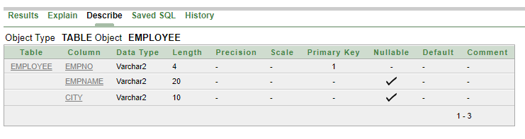

### Project

create table Project(pno varchar2(4) primary key, pname varchar2(15));

desc project;

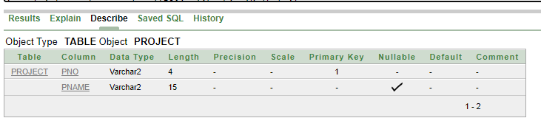

### Part

create table part(partno varchar2(4) primary key, part_name varchar2(15), color varchar2(10));

desc part;

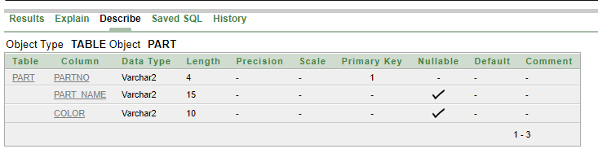

### Use

create table use(pno varchar2(4), partno varchar2(4), primary key(pno, partno), foreign key (pno) references project(pno), foreign key (partno) references part(partno));

desc use;

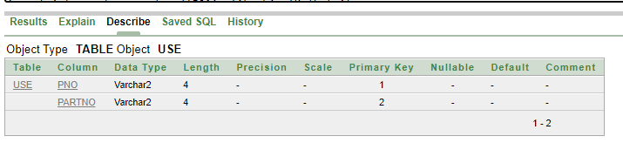

### Works

create table works(empno varchar2(4), pno varchar2(4), primary key(empno, pno), foreign key (empno) references employee(empno), foreign key (pno) references project(pno));

desc works;

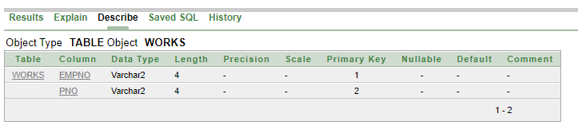

## Value Insertion

### Employee

insert into employee values(‘E01’, ‘Akash’, ‘Kolkata’);

insert into employee values(‘E02’, ‘Anupam’, ‘Mumbai’);

insert into employee values(‘E03’, ‘Sudeshna’, ‘Kolkata’);

insert into employee values(‘E04’, ‘Ria’, ‘Mumbai’);

insert into employee values(‘E05’, ‘Nabanita’, ‘Hyderabad’);

insert into employee values(‘E06’, ‘Jiban’, ‘Kolkata’);

insert into employee values(‘E07’, ‘Souvik’, ‘Delhi’);

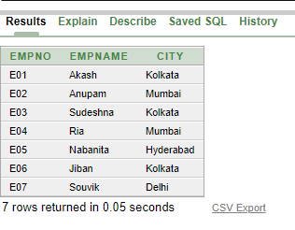

### Project

insert into project values(‘pr01’, ‘ProjectA’);

insert into project values(‘pr02’, ‘ProjectB’);

insert into project values(‘pr03’, ‘ProjectC’);

insert into project values(‘pr04’, ‘ProjectD’);

insert into project values(‘pr05’, ‘ProjectE’);

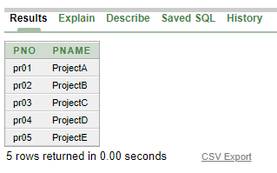

### Part

insert into part values (‘pa01’, ‘Motherboard’, ‘Green’);

insert into part values (‘pa02’, ‘Hard disk’, ‘Black’);

insert into part values (‘pa03’, ‘Sata cable’, ‘Red’);

insert into part values (‘pa04’, ‘SSD’, ‘Red’);

insert into part values (‘pa05’, ‘RAM’, ‘Blue’);

insert into part values (‘pa06’, ‘Cabinet’, ‘Red’);

insert into part values (‘pa07’, ‘Fan’, ‘Black’);

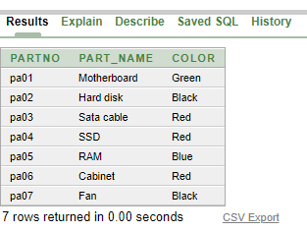

### Use

insert into use values (‘pr03’, ‘pa04’);

insert into use values (‘pr05’, ‘pa03’);

insert into use values (‘pr02’, ‘pa06’);

insert into use values (‘pr03’, ‘pa01’);

insert into use values (‘pr02’, ‘pa05’);

insert into use values (‘pr05’, ‘pa02’);

insert into use values (‘pr02’, ‘pa04’);

insert into use values (‘pr03’, ‘pa05’);

insert into use values (‘pr01’, ‘pa05’);

insert into use values (‘pr05’, ‘pa05’);

insert into use values (‘pr02’, ‘pa07’);

insert into use values (‘pr04’, ‘pa05’);

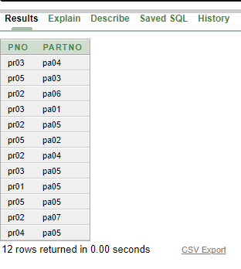

### Works

insert into works values ( 'E01', 'pr03');

insert into works values ( 'E05', 'pr02');

insert into works values ( 'E02', 'pr03');

insert into works values ( 'E03', 'pr01');

insert into works values ( 'E05', 'pr03');

insert into works values ( 'E02', 'pr04');

insert into works values ( 'E07', 'pr02');

insert into works values ( 'E04', 'pr03');

insert into works values ( 'E06', 'pr02');

insert into works values ( 'E04', 'pr01');

insert into works values ( 'E03', 'pr03');

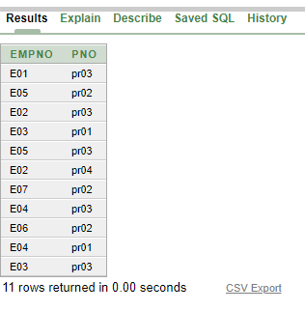

## Queries

1. Give the name of the employees who are working on more than 1 project.
2. select empname, count(pno) from works natural join employee group by empno, empname having count(pno) > 1;
3. select empname from employee where empno in (select empno from works group by empno having count(pno) > 1);

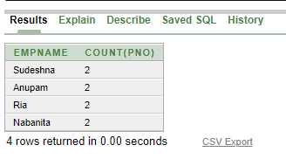

1. Give the name of the city where the maximum employees are located.

select city from employee group by city having count(empno) = (select max(count(empno)) from employee group by city);

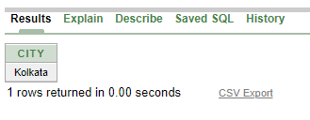

1. Give the part names, which are used in all the projects.

select part_name from part where partno in ((select distinct partno from use) minus (select partno from ((select pno, partno from (select distinct partno from use), project) minus (select * from use))));

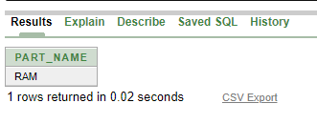

1. Give the name of the projects in which no employees are working whose name starts with ‘S’.
2. select pname from project where pno not in (select distinct pno from works natural join employee where empname like 'S%');
3. select pname from project

minus

select distinct pname from works natural join employee natural join project where empname like 'S%';

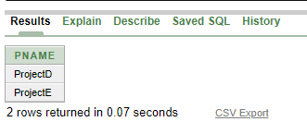

1. Give the name of the project which use maximum red part.

select pname, count(partno) from project natural join use natural join part group by pno, pname, color having color = 'Red' and count(partno) = (select max(count(partno)) from use natural join part group by pno, color having color = 'Red');

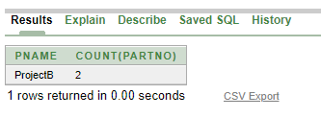

1. Give the name of the projects, which has used exactly 3 parts.
2. select pname from (select pno, count(partno) ct from use group by pno) natural join project where ct = 3;
3. select pname from project natural join use group by pno, pname having count(partno) = 3;

